EXERCISE 3
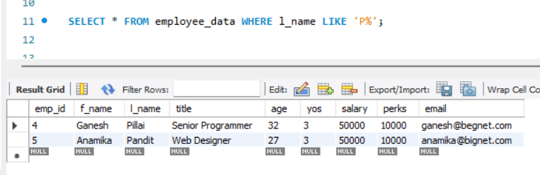
- List all employees whose last names begin with P.

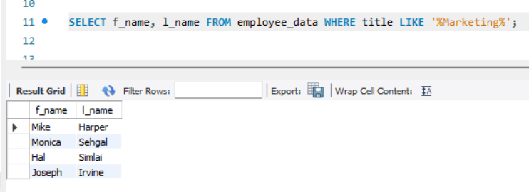
- Display the names of all employees in the marketing division.

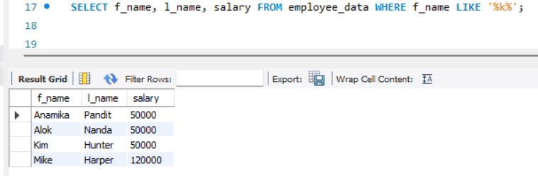
- What will the following statement display

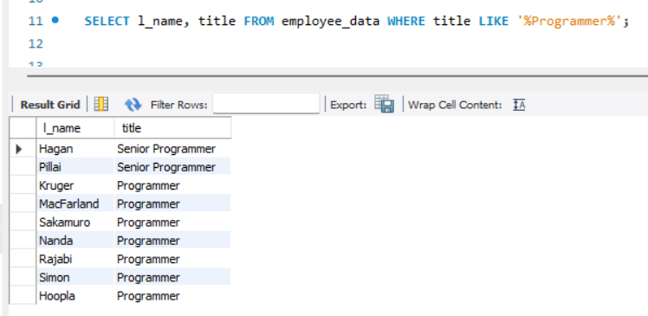
- List the last names and titles of all programmers.

